

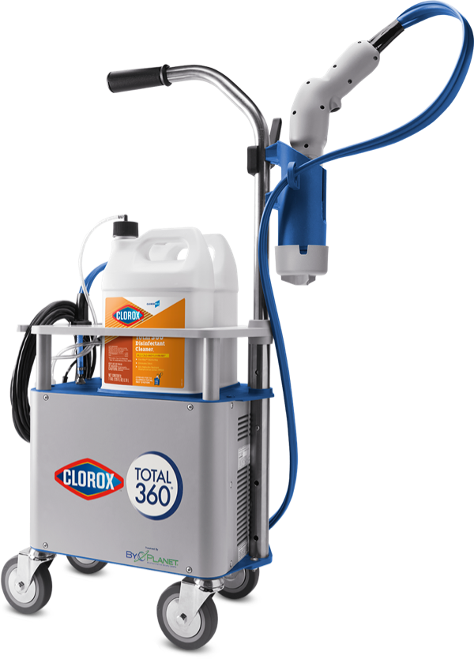
Clorox®
Total 360® System
Electrostatic Sprayer

(EPA Reg. #67619-38)
Clorox®
(EPA Reg. #67619-38) 360® SystemKeep your facility healthier while saving time, money and labor. The innovative electrostatic sprayer, with the patented PowerWrap™ nozzle, delivers trusted Clorox solutions to the front, back and sides of surfaces. Superior coverage for better germ protection.

EPA-approved to kill the COVID-19 virus.‡ Read more in Overview section below.

‡SARS-CoV-2 on hard, nonporous surfaces

Protect your facility with a revolutionary system that helps reduce pathogens like never before. It pairs an innovative electrostatic sprayer with Total 360® Disinfectant Cleaner1, Spore Defense™ Cleaner Disinfectant or Anywhere® Hard Surface Sanitizing Spray to deliver superior coverage in an efficient, cost-effective way. The system uses 65% less solution,* works 75% faster*† and covers 18,000 square feet per hour.
Preparing the Spray Area
- Secure equipment and consider removing paper products from the area to be treated.
- Ensure that individuals without PPE are not present in the area to be treated.
- Don the appropriate PPE. Refer to SDS for specific PPE requirements.
- If needed, remove gross soil from surfaces using your facility’s recommended protocols.
- Place signs or warning indicators outside the treatment area to indicate that cleaning is in progress.

Electrostatic technology enables superior coverage of trusted Clorox® solutions in hard-to-reach places — including the side, underside and backside of surfaces.‡

When used with Clorox® Total 360® Disinfectant Cleaner1
- Kills 99.9% of bacteria in 5 seconds
- 44 organism claims: Kills cold§ and flu viruses, MRSA and norovirus in 2 minutes or less
- One-step disinfecting
- Eliminates odors
- Sanitizes soft surfaces
- Inhibits the growth of mold and mildew for up to 7 days
(EPA Reg. #67619-38)

Specs
Total 360® Electrostatic Sprayer

